**Project on**

**Alumni Management System**

Prepared By

**Rajib Dash**

221-115-075

**Sazida Akther Chowdhury Sani**

221-115-055

**Arnab Chowdhury**

221-115-065

**Sulthan Mahmud Rahi**

221-115-049

Submitted To:

**Department of Computer Science & Engineering**

**Metropolitan University**

Supervisor:

**Nasif Istiak Remon**

Lecturer

**Dewan Ahmed Muhtasim**

Lecturer

**Abstract**

The Alumni Management System (AMS) is a sophisticated software solution to fortify the bonds between educational institutions and their esteemed alumni. It serves as a dynamic nexus, allowing graduates to reconnect with their alma mater and fellow peers while also providing a platform for continuous engagement and collaboration. With AMS, alumni can effortlessly manage their profiles, showcasing their academic achievements and professional milestones.

The aim of this project is to build an Alumni of Metropolitan university online dashboard. It is intended to manage especially the Alumni of college and their respective fields.

The project manages the fresh as well as old graduate students with their respective information in actively participating in making, registering, searching, managing the alumni information for sharing their expertise, network, jobs opportunities and resources.

**Research Problem**

**.** It is difficult to maintain alumni details in a manual system. It's difficult to maintain all historical data.

**.**  It is difficult to maintain important information in documents paperwork.

**.** It is tedious to manage historical data which needs much space to keep all the previous years, ledgers, documents and paperwork.

**Solution**

**.** The design and implementation of the ALUMNI Dashboard system will be available for user use through the web interface.

**.** A user can look at the list of graduates according to year of graduation or a field of study.

**.** He/She can also look at graduates profiles. User can only see name and surname of a graduate, year of graduation and a field of study.

**.** Graduates can also add some information about themselves into the system during the study such as working experience, knowledge.

**.** Graduates can enable to display this information in their profiles for public visitors.

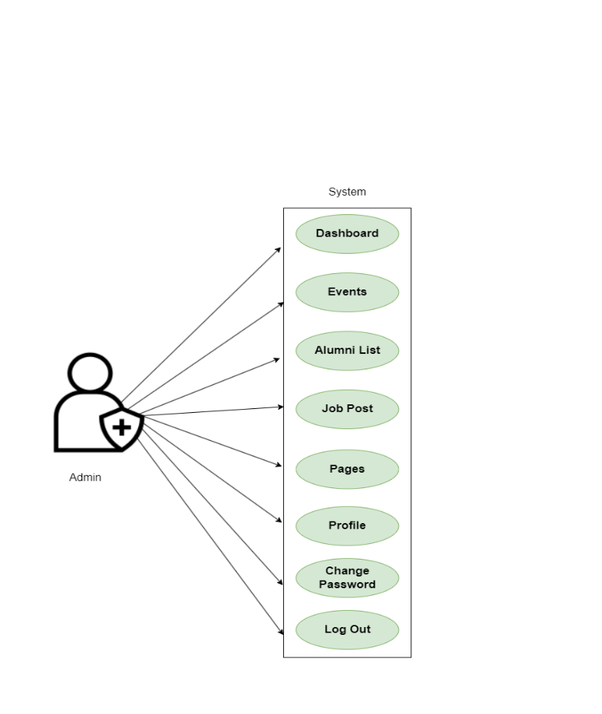

**Use Case Diagram for**

**Admin**

**Admin Module of AMS**

**1. Dashboard:** In this section admin can briefly view total number of events, total courses, new job request, approval of post, total cancelation of job post, total job application and total alumni registered.

**2. Events:** Admin can create new events on this section.

**3. Alumni List:** In this section, admin can view and remove alumni details.

**4. Job Post:** In this section, admin can manage jobs posted by alumni and have rights to approve and cancel that job post.

**5. Pages:** In this section admin can control website pages.

**6. Profile:** Admin can update their profile on this section.

**7. Change password:** Admin can change their account password on this section.

**8. Log out:** Through this button admin can log out from their account.

**Use Case Diagram for**

**Alumni**

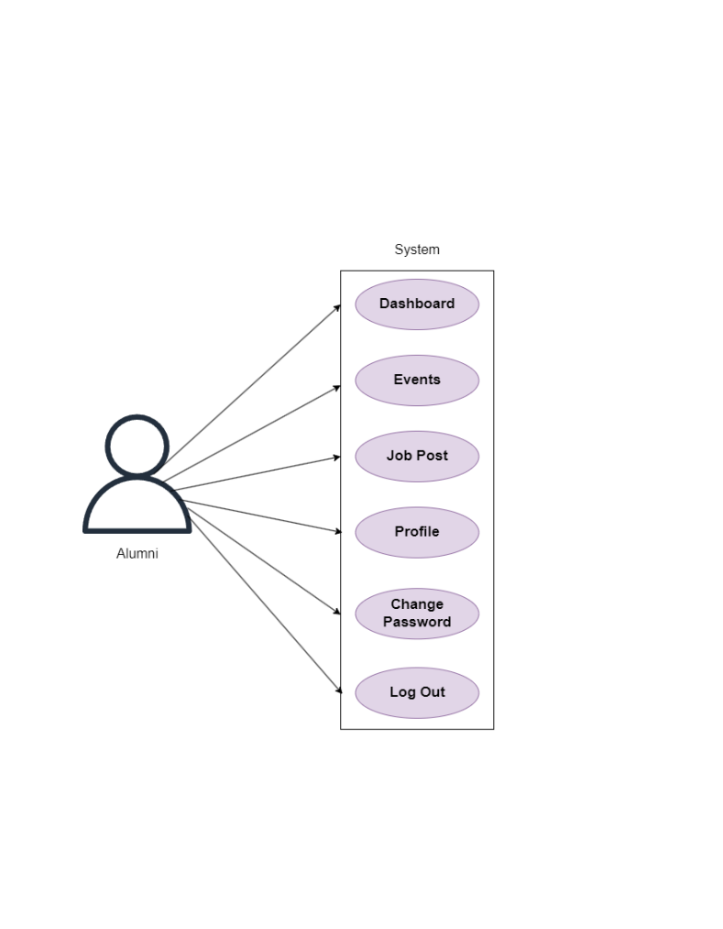

**Alumni Module of AMS**

**1. Dashboard:** In this section, alumni can view total events schedule by university and total job post by university authority or alumni society.

**2. Events:** Alumni can view events details organized by university.

**3. Job Post:** In this section, alumni can manage job post, such as they can add job vacancy news of their workplace or they can update the job post section.

**4. Profile:** Alumni can update their profile on this section.

**5. Change password:** Alumni can change their account password on this section.

**6. Log out:** Through this button alumni can log out from their account.

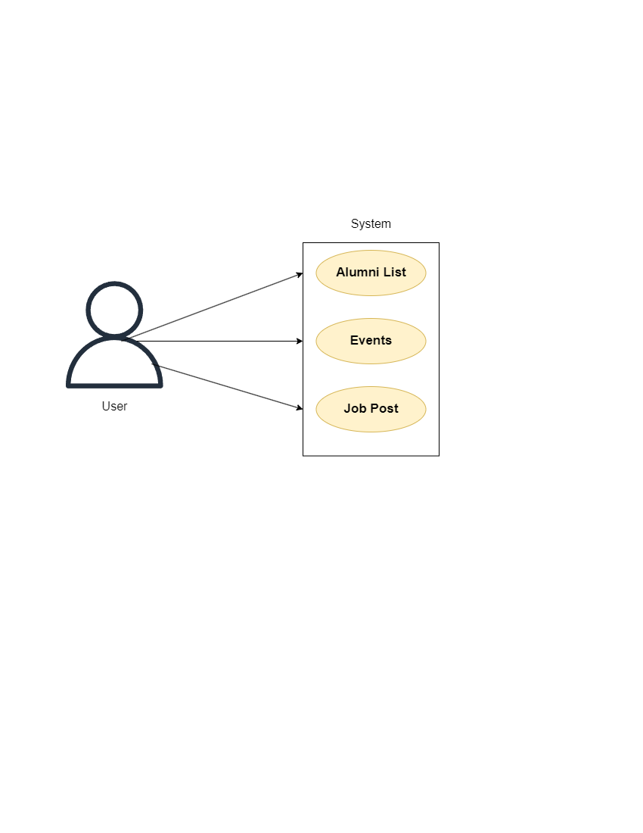**Use Case Diagram for**

**User**

**User Module of AMS**

**1. Alumni List:** In this section, user can see the total list of alumni, and they can view the profile of every alumni.

**2. Events:** User can view the events organized by university.

**3. Job Post:** In this section, user can view the details of job post posted by university authority or alumni society and they can apply for their suitable job based on particular requirements.

**ER Diagram**

